Tarea 1 eigenvalores y engevectores

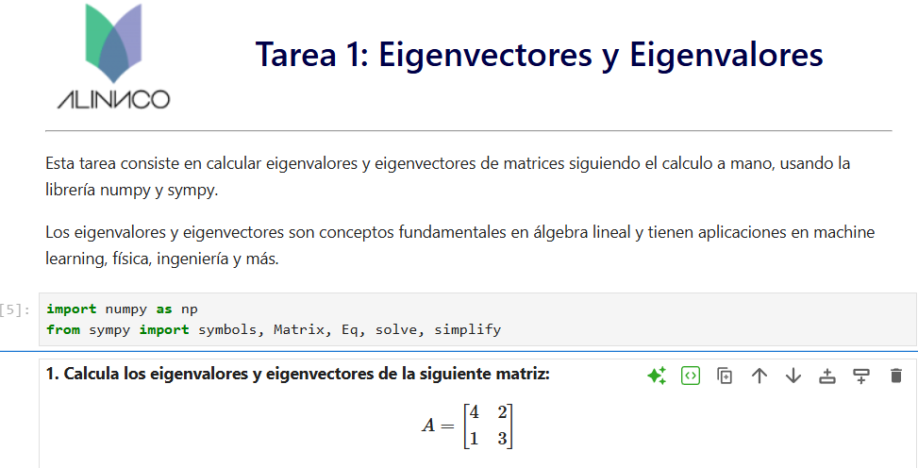
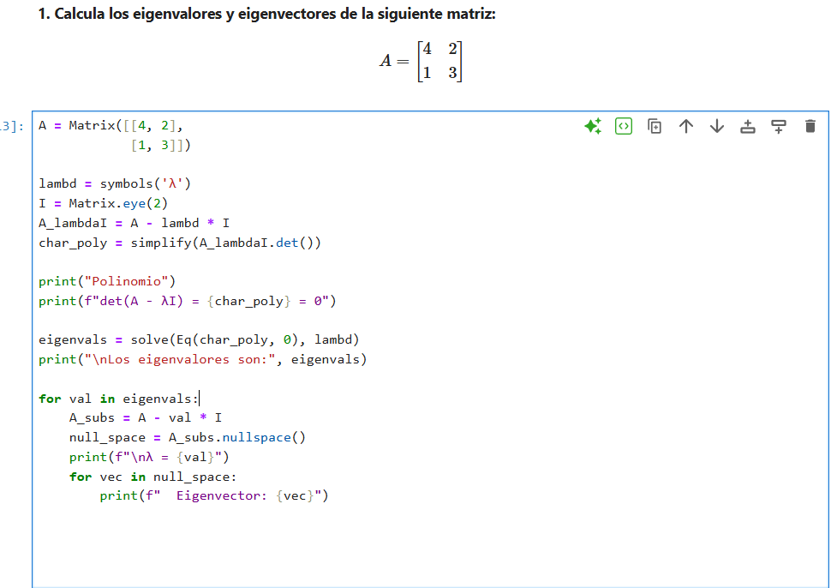
1.-
A = Matrix([[4, 2],
[1, 3]])

λ = symbols('λ')
I = Matrix.eye(2)
A_lambdaI = A - lambd * I
char_poly = simplify(A_lambdaI.det())

print("Polinomio:")
print(f"det(A - λI) = {char_poly} = 0")

eigenvals = solve(Eq(char_poly, 0), lambd)
print("\nlos autovalores son:", eigenvals)

for val in eigenvals:
A_subs = A - val * I
null_space = A_subs.nullspace()
print(f"λ = {val}")
for vec in null_space:
print(f" Eigenvector: {vec}")

1 con numpy

A = np.array([[4, 2],
[1, 3]])

eigenvalues, eigenvectors = np.linalg.eig(A)

print("Eigenvalores:", eigenvalues)
print("Eigenvectores:\n", eigenvectors)

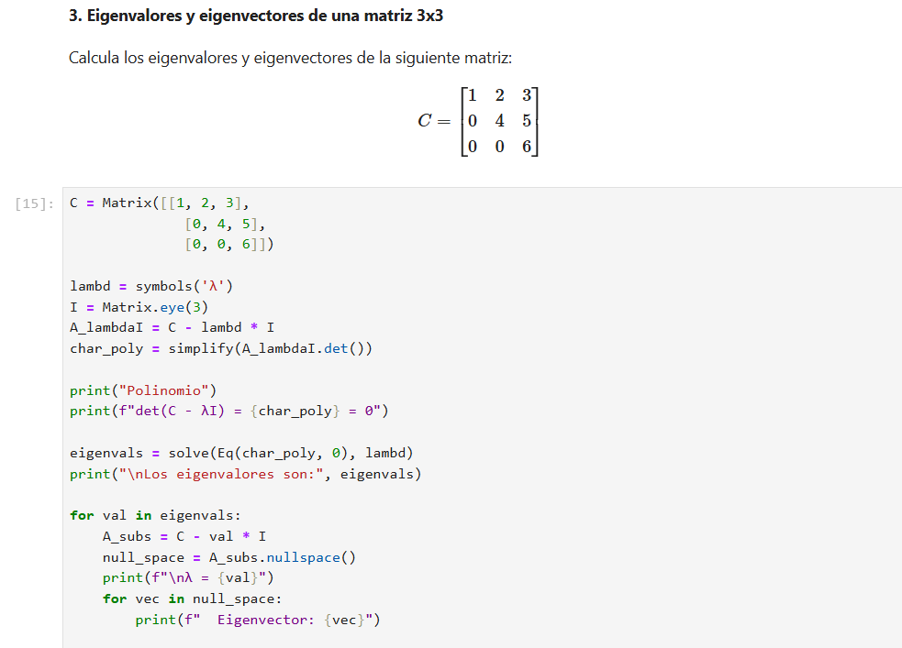

C = Matrix([[1, 2, 3],
[0, 4, 5],
[0, 0, 6]])

lambd = symbols('λ')
I = Matrix.eye(3)
A_lambdaI = C - lambd * I
char_poly = simplify(A_lambdaI.det())

print("Polinomio")
print(f"det(C - λI) = {char_poly} = 0")

eigenvals = solve(Eq(char_poly, 0), lambd)
print("\nLos eigenvalores son:", eigenvals)

for val in eigenvals:
A_subs = C - val * I
null_space = A_subs.nullspace()
print(f"\nλ = {val}")
for vec in null_space:
print(f" Eigenvector: {vec}")

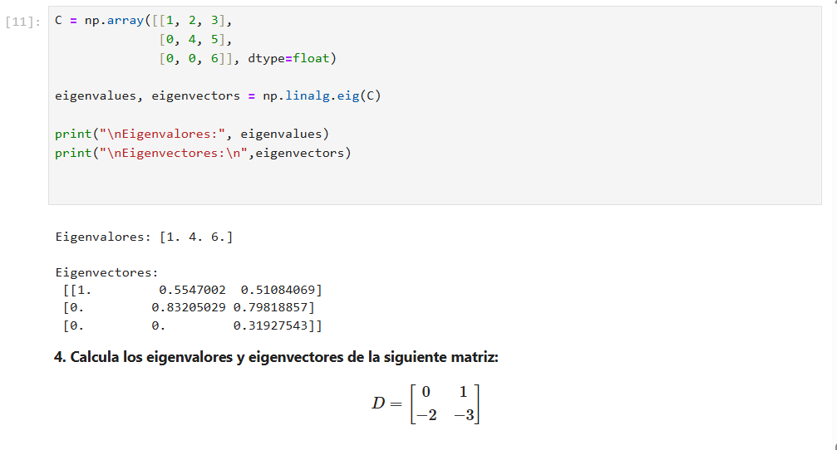

C = np.array([[1, 2, 3],
[0, 4, 5],
[0, 0, 6]], dtype=float)

eigenvalues, eigenvectors = np.linalg.eig(C)

print("\nEigenvalores:", eigenvalues)
print("\nEigenvectores:\n",eigenvectors)

4.-

E = np.random.randint(0, 10, size=(4,4))
print("Matriz E:")
print(E)

eigenvalues, eigenvectors = np.linalg.eig(E)

print("Eigenvalores:", eigenvalues)
print("Eigenvectores:\n", eigenvectors)

